___________________________ ___________________________ Edward J. Markey James P. McGovern

|  |  |  |  |  |
| --- | --- | --- | --- | --- |
| United States Senator |  |  |  | Member of Congress |

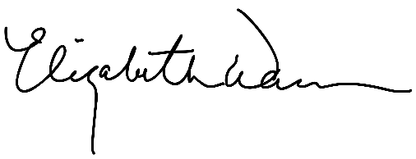___________________________ ___________________________

Elizabeth Warren Patrick Leahy

United States Senator United States Senator

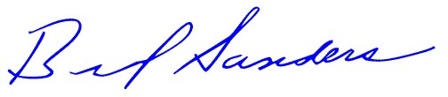___________________________ _______________________________

Bernard Sanders Ayanna S. Pressley

United States Senator Member of Congress

___________________________ _ __________________________

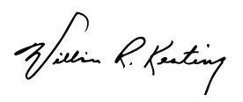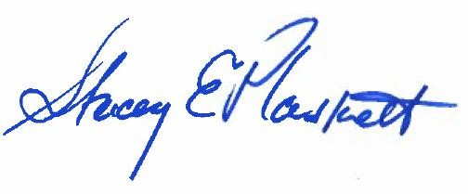Stacey E. Plaskett William R. Keating Member of Congress Member of Congress

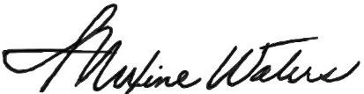 ___________________________ ___________________________

|  |  |  |  |  |
| --- | --- | --- | --- | --- |
| Terri A. Sewell |  |  |  | Maxine Waters |
| Member of Congress |  |  |  | Member of Congress |

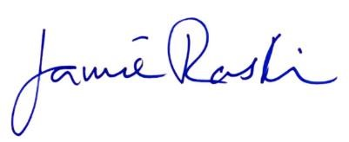___________________________ ___________________________

Jamie Raskin Rashida Tlaib

Member of Congress Member of Congress

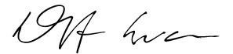___________________________

Dwight Evans

Member of Congress

cc:

The Honorable Antony Blinken

Secretary of State, U.S. Department of State

The Honorable Samantha Power

Administrator, U.S. Agency for International Development